UFC Fight Night: Edgar vs. The Korean Zombie DraftKings Breakdown:

Featherweight Frankie Edgar vs. Chan Sung Jung
Frankie Edgar is one of the very best fighters to step inside the octagon. In his two most recent fights, Frankie has really struggled to wrestle successfully (which is how he’s won a lot of fights) as he has only landed 1 takedown of his last 23 attempts (the 1 takedown was when he needed it the most against Holloway as he was rocked). Frankie’s striking looks to be in its usual, good form as he is light on his feet and mixes it up well, but with him struggling to wrestle offensively will mean a tough path to victory against superior striker, Chan Sung Jung. Jung has power in his hands, is technical, will be bigger than Frankie, and will also have the reach advantage. Jose Aldo was able to wrestle successfully against Jung, but with Frankie’s recent wrestling struggles and his durability being questionable at this point in his career (was knocked out by Ortega, rocked by Stephens, and rocked by Holloway), I see this as a matchup that favors Jung.

For DK: This is a good fight to target. I prefer to play Jung ($9,000) as I believe he wins and is more likely to finish the fight in a winning scenario. There’s a lot of high-priced great plays on this slate, but Jung is still one of my priorities in the $9,000 + range. Edgar ($7,200) is an okay play. There are not many underdogs on this card that I believe have reasonable chances to win, but Frankie has a high floor due to the fact this is a 5-round fight.

Light Heavyweight Volkan Oezdemir vs. Aleksandar Rakić
This is a fantastic fight between two of the best 205lbs contenders. Rakić has looked good in the UFC thus far as he’s showcased very good striking at kicking range with also a wrestling game to go along with it. The biggest hole I see in Rakić’s game is his boxing defense where he is very hittable and was hurt at least once by Devin Clark due to this flaw. This flaw I believe Oezdemir can expose as he is a good boxer with power in his hands. I’ve noticed improvements in Oezdemir’s game as he’s shown better cardio, willingness to push forward, and initiative in landing takedowns. I thought Oezdemir clearly beat Dominick Reyes despite the judges not seeing it that way (I believe recency bias is real with this fight’s odds). That fight with Reyes is encouraging because Oezdemir really pushed Reyes’s limits and Rakić has been the one controlling the tempo in all of his UFC fights thus far, so I am interested to see how he responds to Oezdemir’s pressure and boxing. I am siding with Oezdemir here by KO/TKO finish.

For DK: I like exposure to this fight as a whole, but will be much heavier on Oezdemir ($7,600) as he is one of the underdogs with the most likely chance to win on this card. Rakić is an okay play as he is a finisher, but with Oezdemir improving his grappling & wrestling and also showing a good chin & solid striking defenser, I believe Rakić has a limited path to putting up a big DK score.

Featherweight Doo Ho Choi vs. Charles Jourdain
Excited to see Doo Ho Choi back in the octagon after a long hiatus from the sport of MMA. Choi has power in his hands and a good offensive striker. Choi does show flaws as he’s been rocked in his two most recent fights due to his striking defense not being as defensively sound as it should against threatening strikers (i.e. Swanson and Stephens). Choi has also shown he can be taken down and have a susceptibility to grappling, but I do not believe that will be a difference maker in this fight against fellow, striker, Jourdain. Most likely we get a striker battle here where I favor Choi as he is more UFC experienced, throws & lands strikes at a higher output, has more power, and has fought the better competition. Jourdan is a live underdog as he has power in his hands too and has some explosive strikes with he can utilize as Choi has been hurt in his two most recent fights. Jourdain’s striking output is low though which is why I do not believe it is a likely outcome here.

For DK: I like a little exposure to each fighter here. Choi ($9,400) is a proven finisher in the UFC and may be able to finish Jourdain ($6,800) due to the skill discrepancy and Choi’s big power. I will have a little exposure to Jourdain in large field GPPs because he can MAYBE get a KO/TKO finish.

Light Heavyweight Da Un Jung vs. Mike Rodriguez
I believe the odds are close here due to recency bias. Rodriguez was a big favorite in his most recent fight and lost. Jung was a big underdog in his UFC debut and won by finish. The eye test tells me Rodriguez is the better fighter here. Rodriguez is the superior athlete, the more varied & dangerous striker, has more UFC experience, has a reach advantage, and has fought the better competition. Rodriguez’s biggest flaws are his cardio and takedown defense. I do not expect Jung to test Rodriguez’s wrestling. I actually think it’s more likely Rodriguez will have success wrestling in this bout of the two (please see below). Jung is a decent striker, but I did not like how frequently he let Ibragimov land on him in his UFC debut. The fight was close to being stopped when Ibragimov was landing on Jung excessively. After Ibragimov gassed, Jung was able to take over. I trust Rodriguez more in this spot.
*Jung was taken down by Ibragimov after Ibragimov was completely gassed. While Rodriguez is primarily a striker, I can see him having wrestling success he initiates takedown attempts. 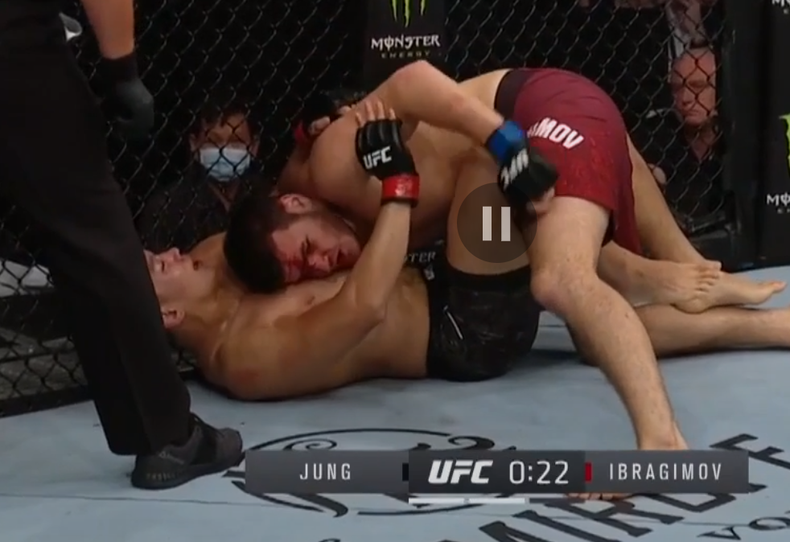
*Same fight. Ibragimov completely gassed was still able to get ahold of Jung. 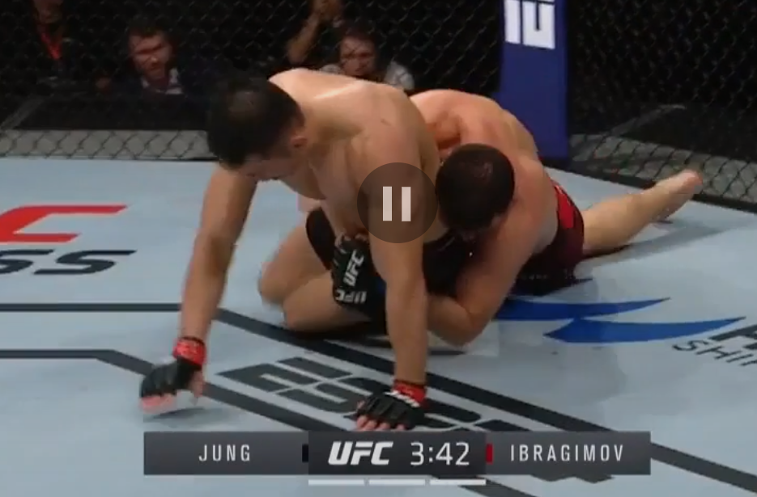

For DK: I prefer to play Rodriguez ($8,300). I believe he is more likely to win this fight and is more likely to finish the fight in a win scenario. Da Un Jung ($7,900) does not interest me on DK in this matchup.

Middleweight Jun Yong Park vs. Marc-André Barriault
Park likes to brawl has he has some power in his hands, but is hittable when striking due to this fighting style. Park has also shown a glaring susceptibility to takedown defense which I believe Barriault can exploit as he is a good wrestler. Barriault is a powerful striker (mainly in bursts), but can use this to exploit Park’s weaknesses to striking defense. As mentioned, Park has some power, but Barriault is durable, so I do not find a KO/TKO finish from Park as a likely scenario. Despite the two-fight losing skid, I believe Barriault gets the job done here as this is a favorable stylistic matchup for him.

For DK: I like Barriault ($8,500) as I believe he is a sneaky play in GPPs. Barriault can land takedowns in this spot with the potential to finish the fight. I will have a little exposure to Park ($7,700) on DK, but not much as he has some odds value.

Bantamweight Kyung Ho Kang vs. Liu Pingyuan
This fight is a favorable stylistic matchup for Kang as he will be bigger than Pingyuan, the better grappler, and the more threatening finisher. Pingyuan is coming off a KO loss to Jonathan Martinez and prior to that was previous rocked (against Martin Day). Pingyuan can be taken down as evidenced in his UFC career which is why I believe Kang will have a lot of success here with his submission grappling skillset. Kang also has some power in his hands which he can use while these two are striking. Pingyuan has some pop in is hands and Kang has been rocked before (i.e. vs. Ishihara and Cannetti), but I find the TKO/KO finish from Pingyuan unlikely here. I do not believe this matchup favors Pingyuan which is why I favor Kang.

For DK: I like Kang ($9,200) as he can wrestle, grapple, and finish the fight in a win scenario. He is also one of the few favorites that is likely to wrestle & grapple; thus, raising his DK point floor. I do not have interest in playing Pingyuan on DK ($7,000).

Bantamweight Raoni Barcelos vs. Said Nurmagomedov
Wow! This fight is really intriguing to me as both fighters have looked great in the UFC thus far. Said has fought the better competition, and has fared well (I thought Scoggins won the fight, but Said held his own striking with him). Barcelos has shown to be the more threatening finisher as he’s finished all three of his UFC opponents. Barcelos is a very interesting fighter as he comes from a high-level BJJ background, with a solid takedown game, and is a solid, powerful technical striker. Barcelos’ well-roundedness and finishing threat make him a tough matchup for a lot of fighters. If a finish where to materialize in this fight, I believe it will come from Barcelos (Said was dropped briefly by Scoggins), but that being said, I expect this fight to be competitive as Nurmagomedov should have the wrestling advantage and is a solid, technical striker himself. I will side with Barcelos here, but a slight lean.

For DK: I prefer to play Barcelos ($8,400). While he does not have the wrestling advantage on paper, IF he can get in top position on the mat against Said Nurmagomedov ($7,800), then he can win via submission or ground and pound. I also believe Barcelos is the more threatening striker. I will not have much exposure to Nurmagomedov has I do not believe he has a high ceiling in a win scenario.

Heavyweight Ciryl Gane vs. Tanner Boser
Gane is a very skilled fighter. He is a varied striker, is fast, a solid wrestler (please see image below), a submission threat, has solid cardio, and is a technical, powerful fighter. Gane will hold a 6-inch reach advantage over Boser. Boser looks to be a solid fighter, but I will keep siding with Gane until he gets matched up with a top 5 opponent because he checks a lot of boxes when it comes to success as a mixed martial artist. The matchup strongly favors Gane. Boser is pretty durable, but the skill discrepancy between these two is wide & that is why Gane is such a big favorite. He is the brightest prospect in the Heavyweight division right now.

*Gane with a really nice level-change for a takedown against Mayes
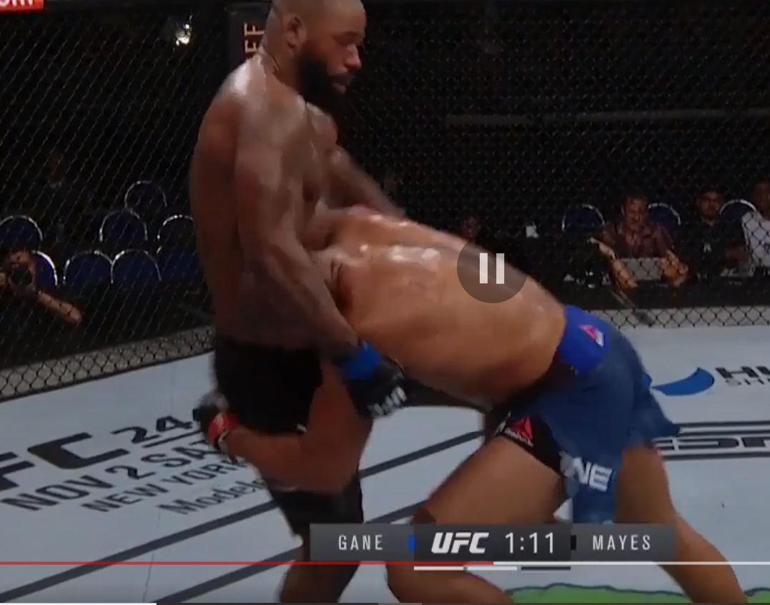

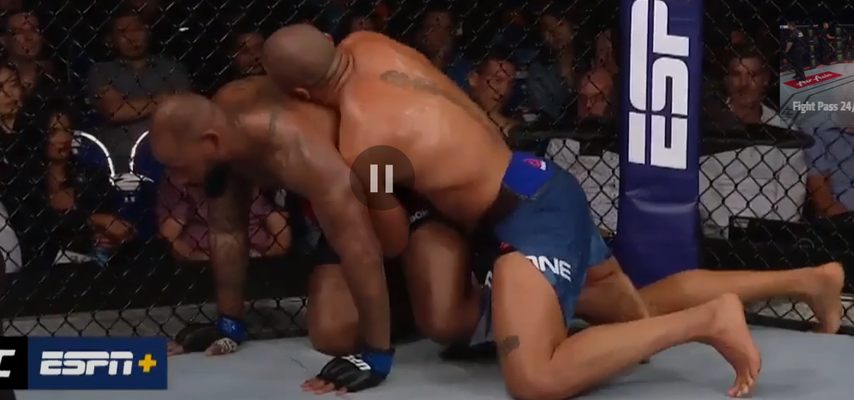
For DK: Gane is an obvious play ($9,600) that I will have some exposure to. There are a lot of other fighters in his DK price range that may be able to outscore him in a win scenario which is why I will be spreading my exposure at the top of the DK fighter pool. I do not have interest in playing Boser ($6,600).
Featherweight Seung Woo Choi vs. Suman Mokhtarian
We could have an upset alert here. Seung Woo Choi is a solid, long technical striker and will face another opponent likely looking to take the fight to the ground. Choi’s first two UFC losses are very understandable as Tucker and Evloev are good wrestlers & grapplers. That being said, I do not like how often Choi gives up his back. It is what cost him a submission loss his last time out against Tucker. I have also seen Choi do this prior to making the UFC as well. Choi will have the striking advantage here, but Mokhtarian’s UFC debut is understandable as Yusuff is a great talent with technical power that swarmed Mokhtarian with power strikes. I do not see Choi doing the same thing here as he not as threatening of a striker as Yusuff. Mokhtarian’s strength is his grappling. I do not believe Mokhtarian is a good wrestler, but Choi has shown a susceptibility to wrestling and grappling which Mokhtarian can exploit. If this fight hits the mat, it will be Mokhtarian who will have the advantage. I will side with Moktarian here for the upset.

For DK: I will fade Seung Woo Choi ($9,300) as there’s a lot of other fighters in his price range I’d would rather target. Mokhtarian ($6,900) is interesting to me in GPPs. I do not expect many people to be on him. I will have some exposure to Mokhtarian in GPPs.

Lightweight Dong Hyun Ma vs. Omar Antonio Morales Ferrer
This is my pick for fight of the night. Ma is always in exciting fights and Morales brings an exciting style too as he is a powerful striker as well. Both fighters are willing to exchange punches, so I believe a TKO/KO finish is likely to materialize here. I will side with Morales here as I trust his durability more. Ma has been hurt in his two most recent fights (i.e. versus Smith and Holtzman) due to his willingness to take damage being accrued over his long UFC career. That being said, Ma is live underdog though as he is much more UFC experienced, has fought the better competition, and hits hard. Morales’ willingness to trade, UFC debut, and level of competition make me not super confident in him winning, but I will lean his way to get the job done here.

For DK: I will have a heavy amount of exposure to this fight as it is one of the more likely ones to end in a finish. I will have more exposure to Morales ($8,800). Ma ($7,400) will very likely put up a big score in a win scenario which is why I will have exposure to him too.

Flyweight Alexandre Pantoja vs. Matt Schnell
Another great fight on display here. I said it last week and I’ll say it again…I am so glad the Flyweight division is still in tact (didn’t say this exactly, but paraphrasing)! Schnell has looked very good in his two most recent bouts showcasing his dangerous guard on the mat. Schnell is also a good striker as he is technical and fast. Pantoja is the more threatening striker, the more aggressive striker, and the better credential BJJ practitioner. I expect this fight to be competitive with Pantoja in the lead. Also, if a finish were to materialize, I believe it will come from Pantoja (Schnell has been finished via strikes twice in the UFC) due to the threat of power he has striking and threat of submission on the mat.

For DK: This is a reasonable fight to target. Pantoja ($9,100) is sneaky due to his finishing upside and price range. Schnell ($7,100), I believe is unlikely to finish this fight, but I would not be surprised to see him win due to the improvements he’s made and his ability to make this fight competitive.

Bantamweight Alateng Heili vs. Ryan Benoit
Both of these fighters are similar in that they are low output strikers with power in their hands. The glaring differences I see are durability and wrestling (both in favor of Benoit) which may or may not play a role here. I believe Benoit is the better fighter, but is lengthy time away from the Octagon is a concern. Benoit as big power in his hands (hurt Serrano, Moreno, and Pettis), is a solid wrestler, and is much more UFC experienced than Heili. Heili is a decent striker, but I do not expect him to have wrestling success here like he did in his UFC debut against Danaa. I will side with Benoit as I believe he is the more threatening fighter, but I do not expect either fighter to easily win rounds, so I see this fight as very competitive should a finish not materialize.

For DK: I do not have much interest in this fight. If a finish does not materialize, I do not expect the winner to put up a big score. I have more interest in Benoit ($8,200) of the two on DK as I believe he is the more threatening striker that is also more durable.

Amanda Lemos vs. Miranda Granger
I believe both women excel the most at submission grappling, but I am unsure if this fight hits the mat. Lemos looks to be the better wrestler, but her long layoff and competition are question marks that will likely be addressed against undefeated, Granger who fought in August. Granger will likely throw more volume, but Lemos looks to have more power and is more elusive (while she’s fresh). This is a tough fight to call. I will side with Granger to win, but questions will likely be answered for Lemos as this is a very different matchup than she had in her UFC debut.

For DK: I will fade Granger ($8,900). She is expensive on DK and unlikely to finish this fight. I’d rather target other fighters in her range. Lemos ($7,300) is a live underdog with reasonable odds to win. I question Lemos’ upside though in a win scenario.

AJ’s Flash Knockdown Picks:
Lock them in (cash games):
- Chan Sung Jung $9,000
- Ciryl Gane $9,600
High priced fades:
- Miranda Granger $8,900
- SeungWoo Choi $9,300
Low-owned live underdogs:
- Suman Mokhtarian $6,900
- Volkan Oezdemir $7,600
- Charles Jourdain $6,800
Underdogs (relative to DK pricing below $8,100) to consider in cash games:
- Frankie Edgar $7,200
Low-owned favorites:
- Marc-Andre Barriault $8,500
- Kyung Ho Kang $9,200
- Mike Rodriguez $8,300

