UFC Raleigh DraftKings Breakdown

Heavyweight Curtis Blaydes vs. Junior dos Santos
A great heavyweight main event we have here! If Rozenstruik beats Ngannou in March, I believe the winner of this bout will face Rozenstruik for a #1 contender bout (or possible interim title bout); otherwise, Ngannou is the clear #1 title challenger AFTER Miocic and Cormier fight for a third time. With huge steaks on the line, I like Blaydes in this matchup. Blaydes’ wrestling is very good as he has shown to land takedowns in volume over the course of 15 minutes, control his opponents on the mat, be very physical when he gets the body lock position on his opponents, and land good ground & pound. Blaydes will be at a striking disadvantage in this fight despite have a slight reach advantage as JDS is the superior technical striker with superior power. JDS will need to counter Blaydes as Blaydes closes distance AND/OR defend takedowns long enough to keep the fight standing to earn the TKO/KO finish. JDS can win via finish, but I trust Blaydes to win rounds more due to his wrestling and cardio advantages. Dos Santos generally has good takedown defense (defended several takedowns in his first bout against Stipe), but he was taken down several times by Cain Velasquez. While Blaydes is not as credentialed as a pure wrestler as Cain, he has shown to be very physical with the body lock position against the majority of his opponents, so I expect Blaydes to land takedowns successfully. I see JDS making it through the first few rounds should this fight hit the mat because he is a very good submission grappler, but being on his back certainly won’t help him win rounds. This fight reminds a bit of Colby Covington versus Robbie Lawler with more variance due to the bout taking place at heavyweight.

For DK: This fight is an obvious target. I prefer to play Blaydes ($9,000), but I will have exposure to both fighters. Dos Santos ($7,200) very likely needs to earn a TKO/KO to win this bout which is intriguing for his DK salary.

Welterweight Rafael dos Anjos vs. Michael Chiesa
I am happy to see Chiesa make his way up the ranks at 170lbs. Chiesa is big for the weight class despite fighting the majority of his UFC career at 155lbs. RDA, to me, is the superior striker and grappler, but Chiesa’s size advantage combined with the fact he is a decent wrestler and grappler himself can certainly mitigate RDA’s advantages on the mat. If RDA, can earn top position he may be able to submit Chiesa especially if Chiesa gets tired early in the fight which has happened in the past (i.e. against Pettis). Interesting fight, but I will side with RDA as he is the superior fighter in terms of grappling, striking, and wrestling.

For DK: It is hard for me to ignore that Chiesa ($7,300) has been finished in all of his UFC losses and RDA ($8,900) is the superior fighter on paper here. I will have some exposure to RDA for the grappling and finishing upside. I will have small amount of Chiesa in 20+ lineups.

Featherweight Nik Lentz vs. Arnold Allen
Potential upset alert! Prior to tape study, I felt pretty good saying Allen is in a favorable matchup against shore notice replacement, Nik Lentz. However, after tape study, I believe it is in fact Lentz that has the more favorable matchup on paper. Allen is a solid, well-rounded fighter that has showcased submission capabilities (i.e. submitting Mads Burnell), striking, and wrestling (i.e. versus Amirkhani). The most susceptible area of Allen’s game is his defensive wrestling which is what very experienced and credentialed wrestler, Nik Lentz can look to exploit. I expect Allen to get the better of the striking exchanges, but not by a wide margin as Lentz is an adequate striker that is pretty aggressive and is very durable. Lentz is coming off a TKO loss to Charles Oliveira in May, so maybe Allen can hurt Lentz, but Allen does not hold any TKO/KO victories in the UFC thus far and I still consider Lentz a durable fighter despite the recent loss via strikes. Lentz will be dropping to 145lbs which MAYBE affects his cardio and durability, but no guarantee. All in all, the odds on this fight should be closer and I will actually side with the wrestler here as I place more emphasis on stylistic matchups rather than intangibles when doing my analysis.

*The following images are from Allen’s bout against Mads Burnell
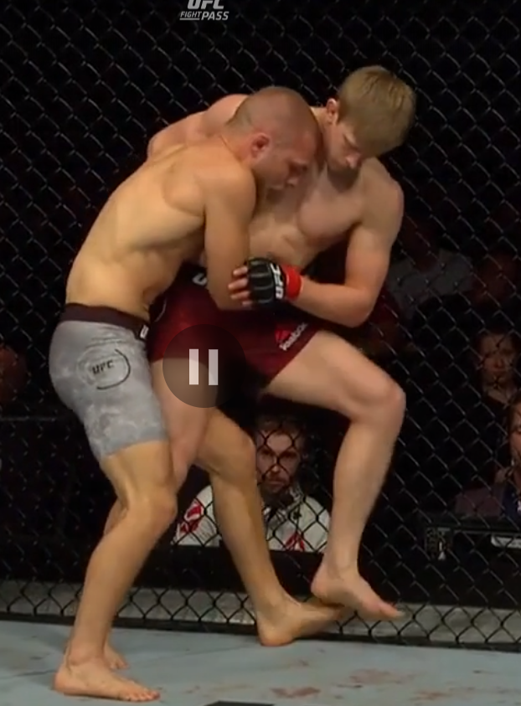
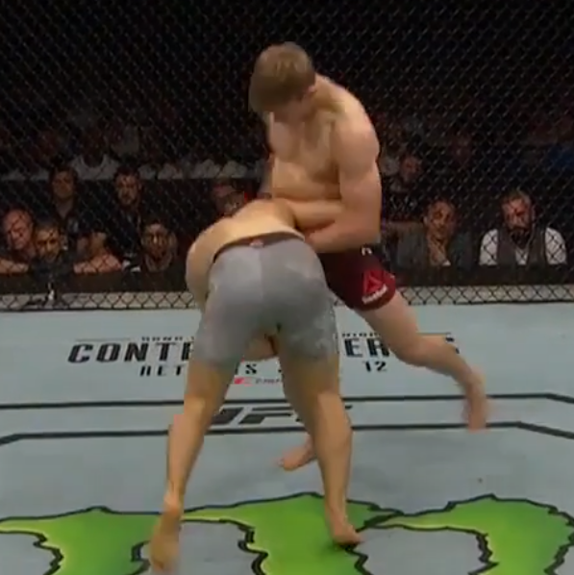

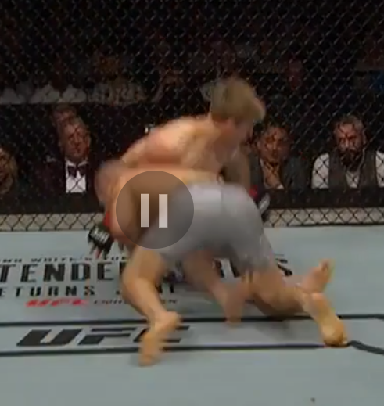
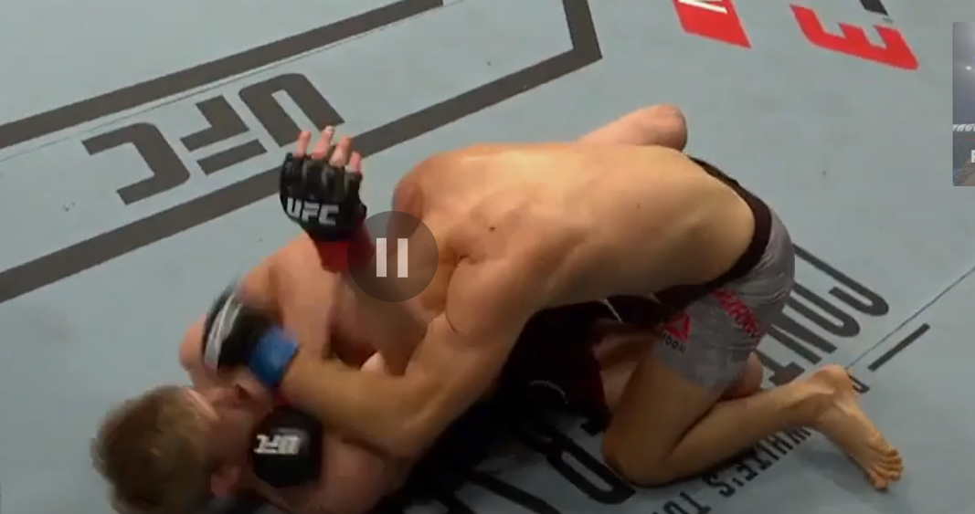

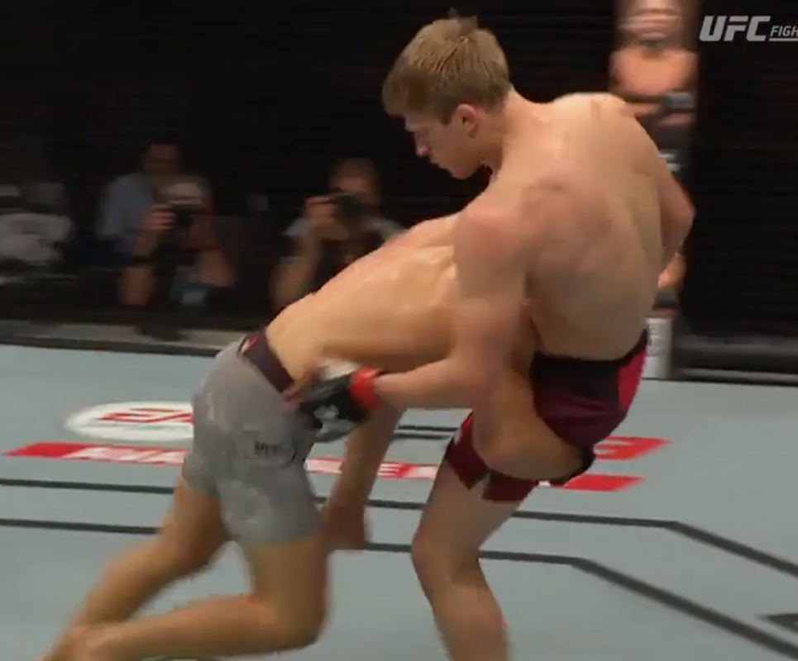

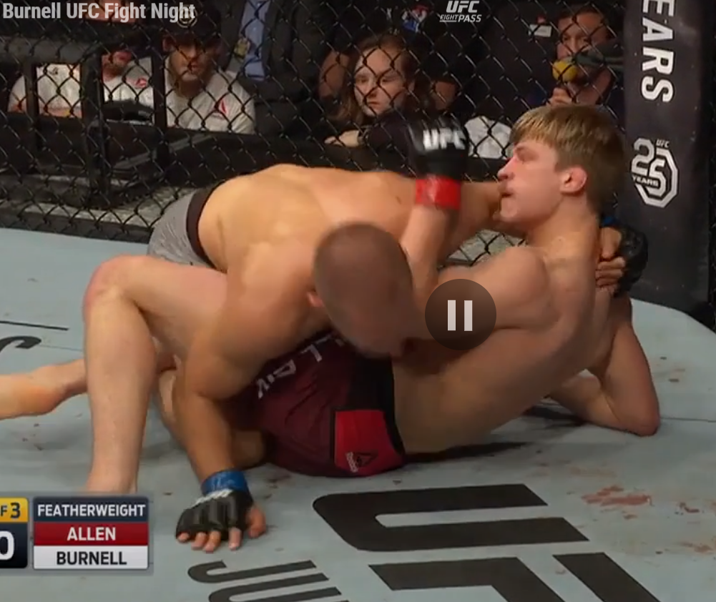
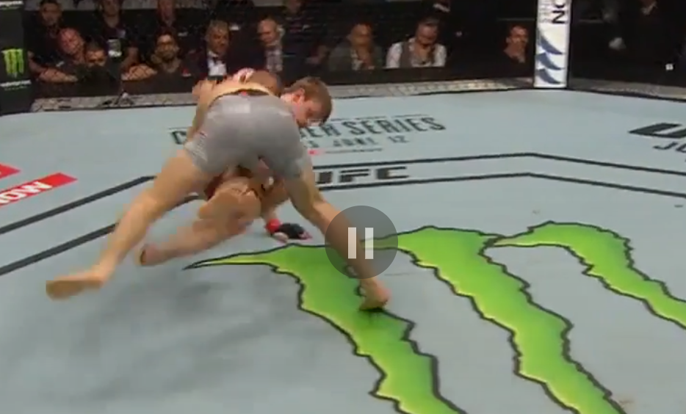

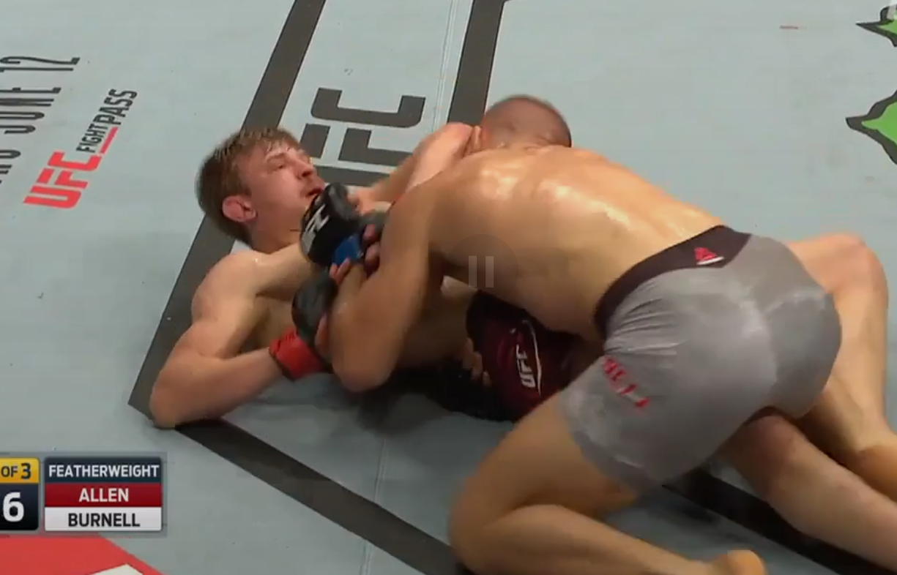

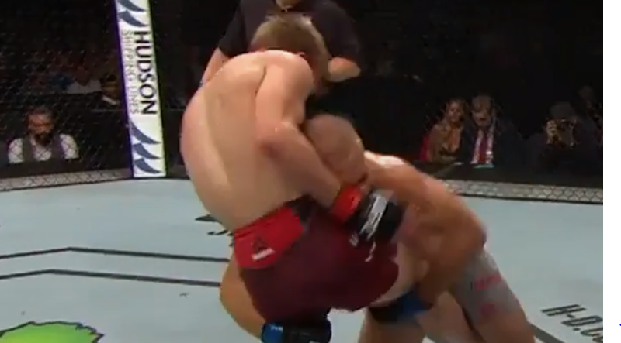

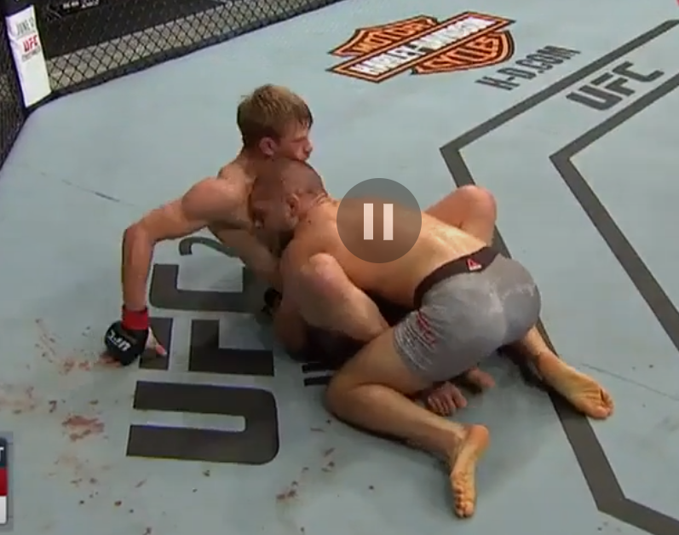

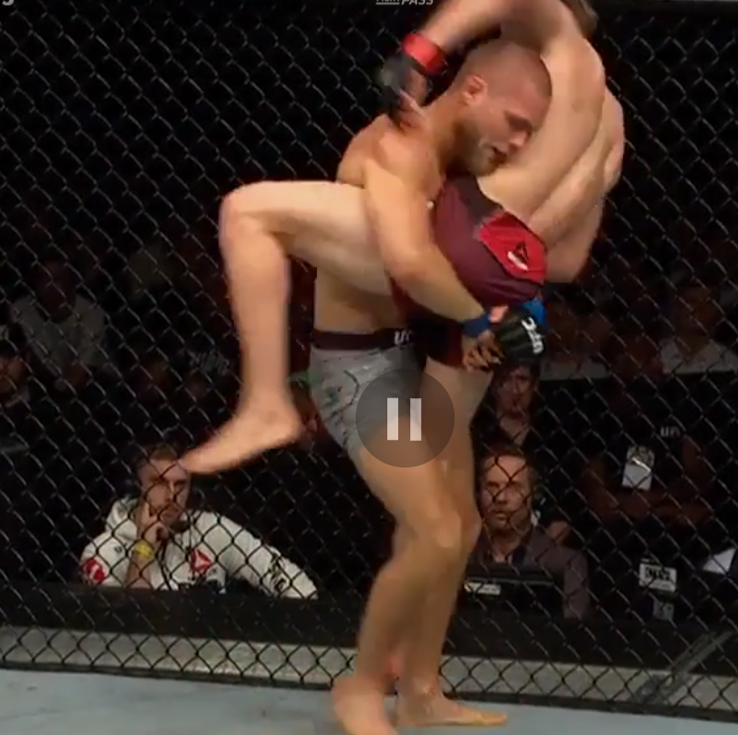

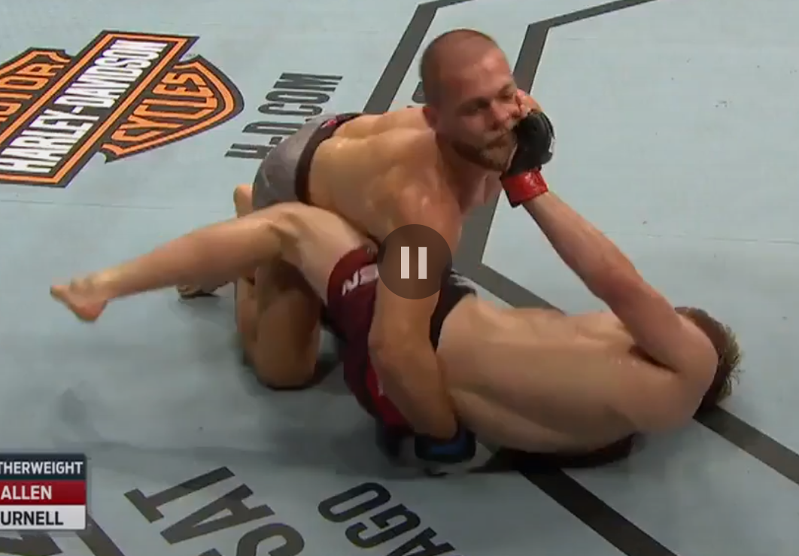
*Against Makwan Amirkhani
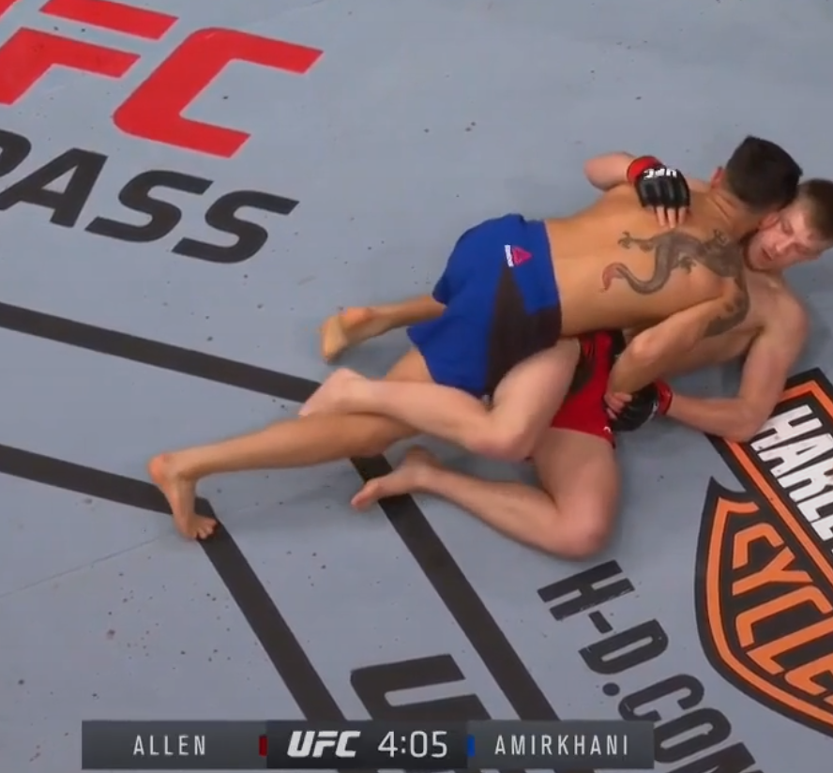

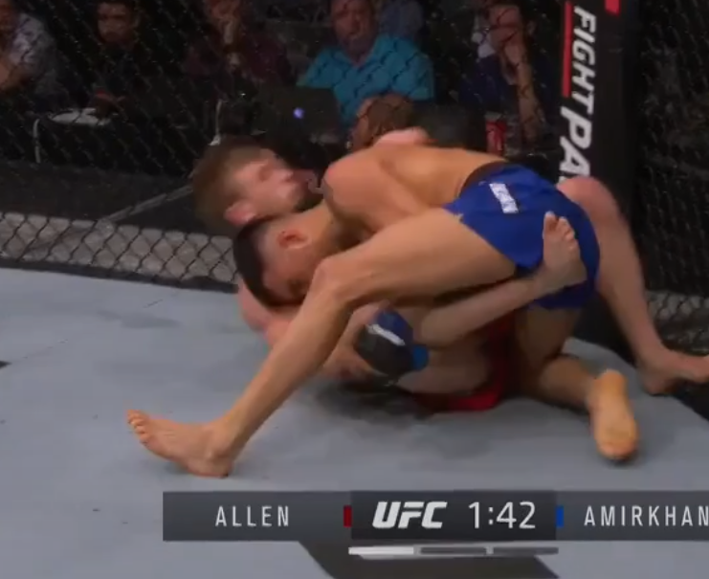

For DK: I will fade Allen ($9,200) as he is unlikely to finish the fight nor land a sufficient amount takedowns and/or significant strikes to pay off his salary. Allen could also realistically lose in this matchup. Lentz ($7,000) does interest me both as a cash game (50/50s, double ups, head to heads and triple ups) consideration and a GPP play.

Flyweight Jordan Espinosa vs. Alex Perez
Espinosa has an exciting fighting style as he is a proven finisher with agility and power in his hands, but is open defensively (keeps his hands low while in striking exchanges and is susceptible to submissions on the mat). As a result, Espinosa has been rocked in striking exchanges (pre-UFC debut) and submitted on the mat in the UFC (i.e. by Matt Schnell). I hope that Espinosa has made improvements defensively as I do believe he is a good, talented athlete overall. That being said, Perez is a much more technical and superior fighter (hence the bet) here as Perez has a good defensive guard, is aggressive, has power in his hands, can land strikes in volume, is a good wrestler, and a very good submission grappler (especially from the front head lock position). Perez is the rightful favorite here due to his technical advantages both in the striking department and on the mat.

For DK: I like some exposure to Perez ($9,100). He may come in at a lower ownership than RDA ($8,900), Bevon Lewis ($9,300), and Montel Jackson ($9,400) and could legitimately be the highest scorer amongst the 4 fighters. I will not have any exposure to Espinosa ($7,100) on this DK slate.

Women's Strawweight Hannah Cifers vs. Angela Hill
Hill is an agile, high volume striker with improvements of grappling added to her MMA game (i.e. submission attempt off her back against Yan Xiaonan) which I believe will ultimately win her this matchup against Hannah Cifers. Cifers is a striker, but I believe Hill has the superior technique, volume, and movement. I could see Cifers making this fight close, but the pick for me here is Hill.

For DK: I will not have much (if any) exposure to this fight. Cifers ($7,600) is a cash game (50/50s, double ups, head to heads and triple ups) consideration as are Kish ($7,500) and Lentz ($7,000) as all three fights are very likely to go to a decision and as a result, each have a safe DK point floor.

Light Heavyweight Jamahal Hill vs. Darko Stošić
It was hard to judge Hill’s overall MMA game from his contender series fight as the fight played out in striking exchanges where he is best and won the fight via stoppage. However, going back to his pre-UFC fights, I have to say that his wrestling defense and grappling can be much improved. The opponent he faced in the images below took him down several times and Darko comes from a Judo background, so I expect Darko to land takedowns in this fight which could ultimately win him the fight, but I am not sure how his cardio will fair down the stretch if he cannot control Hill on the mat for a decent length of time. Stošić may also win this fight via TKO/KO while these two are standing in striking exchanges as he throws powerful strikes (but at a low volume) and I’ve seen Hill rocked before in pre-UFC footage. Hill himself may also earn the TKO/KO victory as Stošić was knocked down by Devin Clark and if Stošić gets tired, Hill can search for the finish should he still be relatively fresh in the scenario.

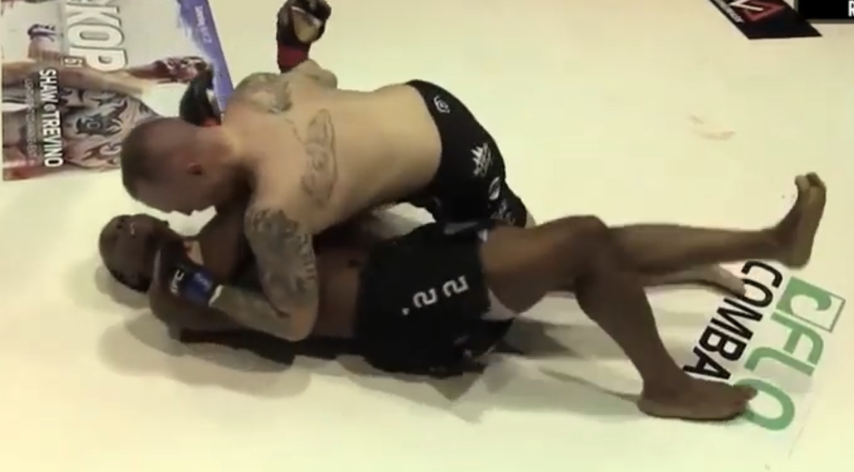
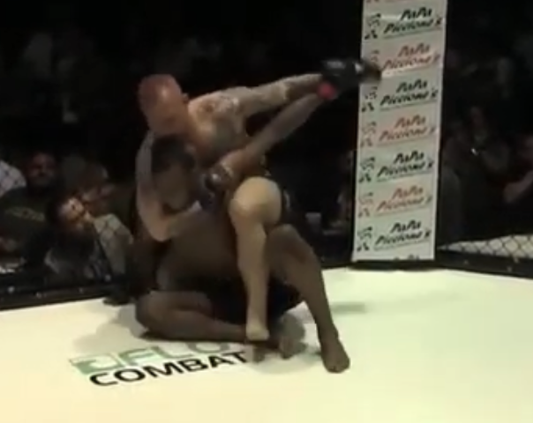

For DK: I prefer to play Stošić ($7,700) as he has a very reasonable chance to win this fight via wrestling and grappling with potential to finish. I will have limited exposure to Hill ($8,500).

Women's Flyweight Justine Kish vs. Lucie Pudilová
I expect there to be a noticeably length disparity between these two ladies as Pudilová used to fight at 135lbs and Kish has fought at 115lbs and the two are meeting for this bout at 125lbs. Pudilová should be hungry for a win here as she is on a 3 fight losing skid despite very valiant efforts in all three fights against good competition (i.e. Aldana, Carmouche, and Antonina Shevchenko). This is Kish’s first fight inside the octagon in about 2 years, so it’ll be interesting to see what he looks like against a very active, Pudilová. Kish is an aggressive, high volume striker, but is open defensively & can improve her head movement. I like Pudilová in this spot as I believe she is the more effective striker with superior defense (good footwork + movement). Pudilová will also have a reach advantage and can have success on the mat if she pursues grappling as she is a capable grappler combined with her length advantages. Furthermore, Kish’s guard was passed numerous times against Ashley Yoder and Felice Herrig (was very nearly submitted, but showed INSANE toughness) at 115lbs. (please see below).

*mounted against Ashley Yoder
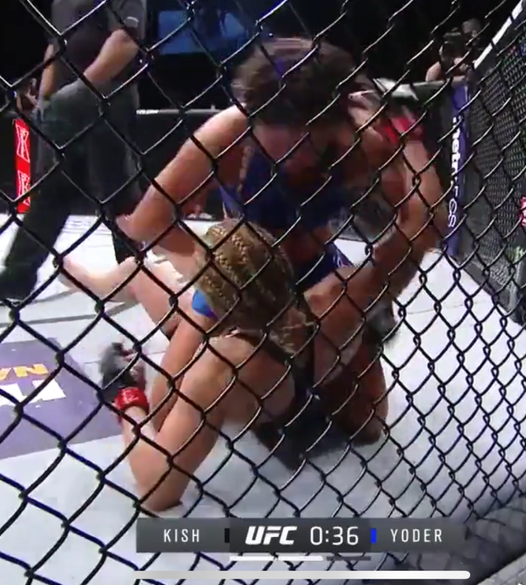
*back taken and nearly submitted by Herrig
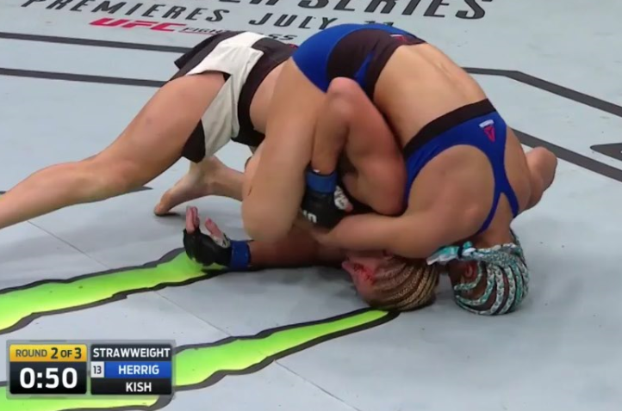

*mounted by Herrig – Herrig passed Kish’s guard an excessive amount of times on the mat.
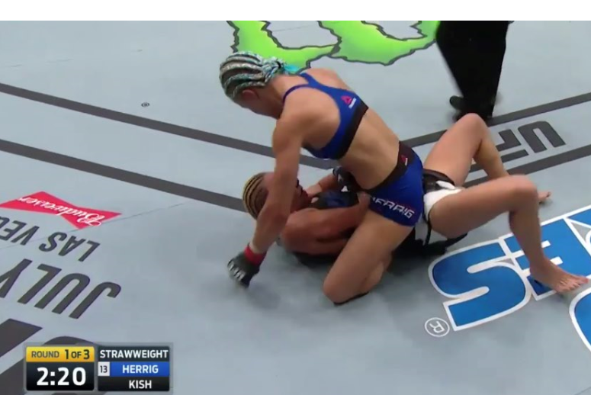
I believe Pudilova wins this fight via clear decision 30-27.

For DK: I do not have much interest other than a cash game (50/50s, double ups, head to heads and triple ups) underdog consideration for Kish ($7,500) as this fight is very likely to go the distance where Kish can land an adequate amount of significant strikes; thus, having a safe DK point floor.
Bantamweight Montel Jackson vs. Felipe Colares
Montel Jackson looks to be a very bright prospect. Jackson has power in his hands, a long reach for the division, very good wrestling, good cardio, and good athleticism. Colares’ best skillset is his submission grappling which will be very tough for him to implement as he will be at the wrestling disadvantage here by a wide margin. Colares has not been finished via strikes in his pro MMA career, but I predict Jackson will earn a TKO/KO finish because I believe the striking disparity between these two fighters is wide combined with the fact Jackson has power in his hands, has a decent reach advantage, and is a precise striker.

For DK: I like Jackson ($9,400) for cash games (50/50s, double ups, head to heads and triple ups) and GPPs as he is a huge favorite and rightfully so as this is very favorable stylistic matchup for him. He and Lewis ($9,300) are equal plays for me on DK because I think they both have safe DK point floors with added upside of finishing and wrestling. I will fade Colares ($6,800).

Women's Bantamweight Sara McMann vs. Lina Länsberg
Very interesting fight, we have here as this is a favorable stylistic matchup for McMann on paper, but with Länsberg improving her takedown defense and grappling in her two most recent bouts, it makes this fight closer than it otherwise would; hence, the close odds on the betting line as of 4:33pm CST. This is McMann’s first fight in about 2 years in the UFC’s octagon. McMann is a very strong wrestler with a threatening top position game as she looks to advance position and land excessive ground & pound or hunt for a submission. McMann has been submitted multiple times (Marion Reneau, Amanda Nunes, and from Ketlen Vieira – all women are strong BJJ practitioners). While I believe Länsberg has improved her grappling, I do not think she can submit McMann unless she can hurt McMann in the clinch with a body strike (Länsberg is strong in the clinch and very decorated in Muy Thai) and choose to finish via SUB even if the opportunity for a TKO finish is there (it would be a matter of Länsberg’s preference should this scenario happen). As for the striking, I favor Länsberg, but I expect McMann to land takedowns here if Yana Kunitskaya was able to against Länsberg (5 of them), so ultimately, I will lean with McMann as I believe she should have success on the mat where she can earn top position, threaten with submissions, and land excessive ground & pound.

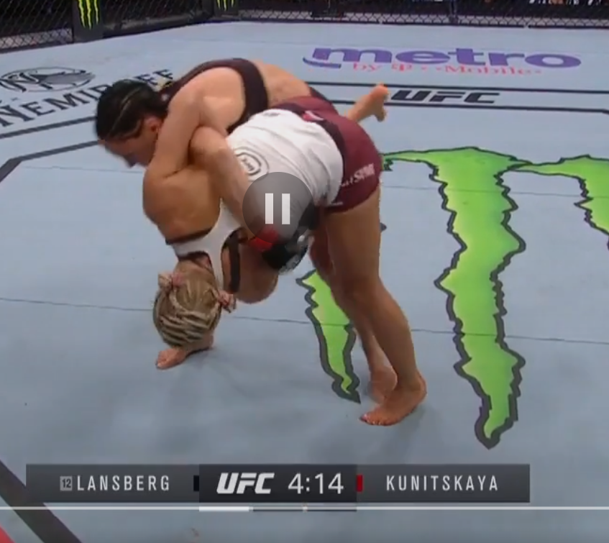

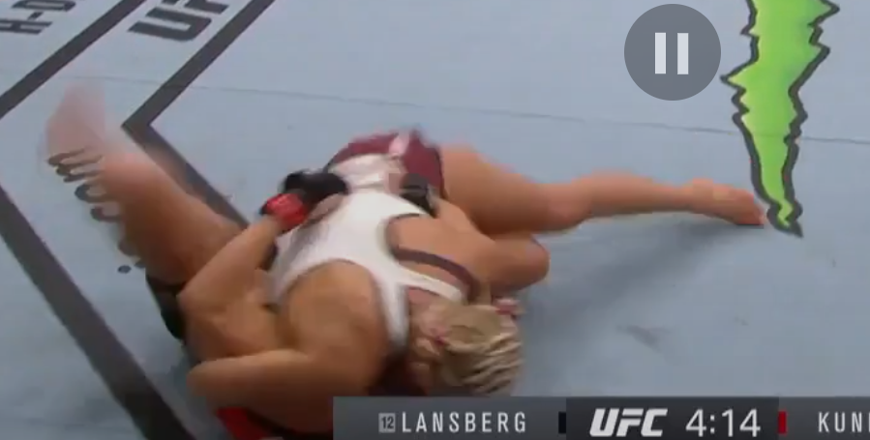

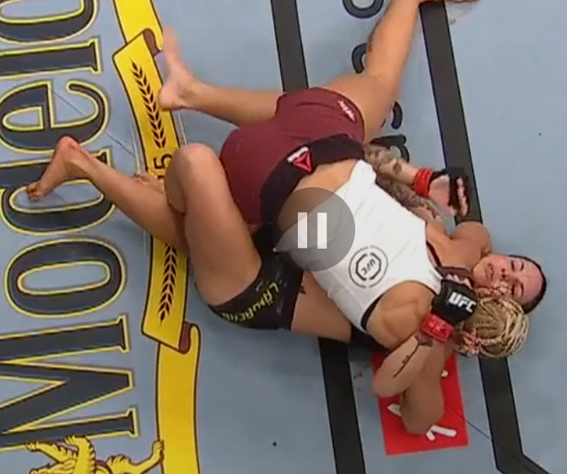

For DK: I like a little bit exposure to both fighters here. I will likely have more exposure to McMann ($8,400) because I think she has more paths to putting up a big score, but Länsberg ($7,800) can realistically earn a finish despite the odds of that happening being not very favorable.

Bantamweight Brett Johns vs. Tony Gravely
It’s nice to see Johns scheduled back in the octagon after a lengthy layoff. Johns is coming off two losses, but it’s very understandable as Sterling and Munhoz proved to be difficult matchups for him being that they are both superior submission grapplers and strikers (at the time of the matchups). I am optimistic that we see improvements from Johns here as I like his overall game. Johns is aggressive, a solid boxer, very durable, a good submission grappler, and a good wrestler. His opponent on Saturday, Tony Gravely, will likely try to implement a wrestling and grappling oriented game plan which will likely work to Johns’ benefit. Gravely is a strong, physical, athletic wrestler and solid offensive grappler, but similar to Tim Elliott and Brain Kelleher last week, I question his defensive grappling. Gravely has been put in bad spots on the mat including his DWTNCS fight (which he went on to win) and while he did not get submitted in some of these matchups when he gave up a dominant position on the mat, it presents an opportunity for Johns to capitalize on as he is the better grappler of these two. I favor Johns here to win by submission.

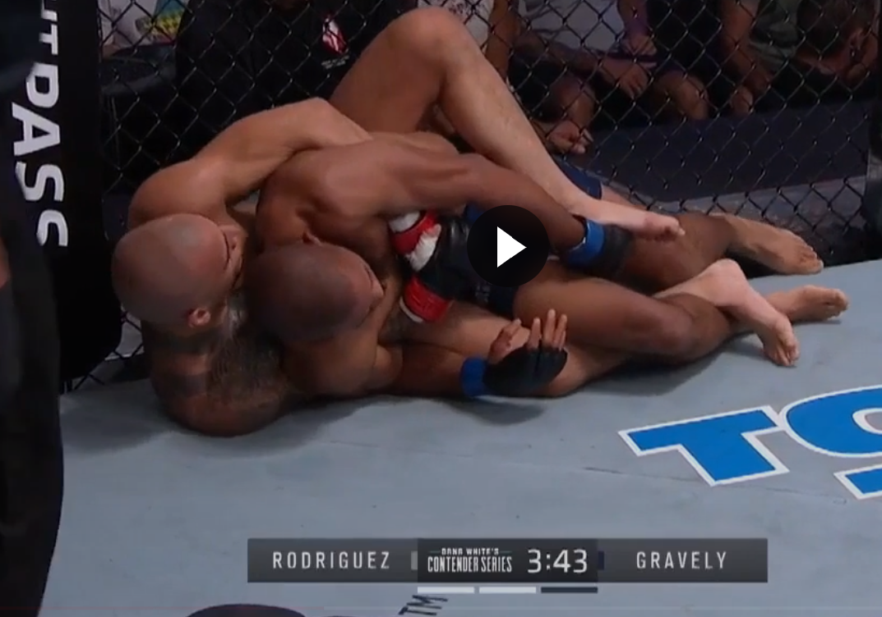
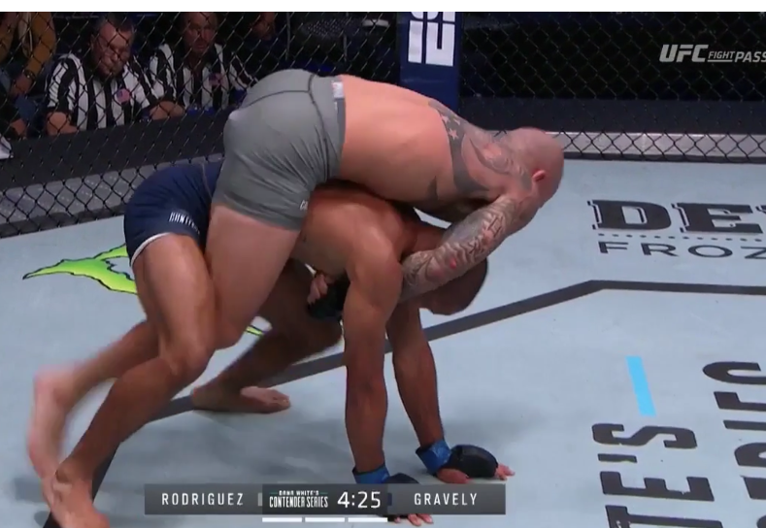

For DK: I think this is a solid fight to target and what should be a low ownership. I will have more exposure to Johns ($8,000) as I like the $200 discount and is stronger likelihood of finishing the fight. I do not think Gravely ($8,200) is a bad play as he can realistically put up a big score should he win this fight via wrestling and grappling (Sterling and Munhoz put up BIG DK scores against Johns when the fought him).
Featherweight Herbert Burns vs. Nate Landwehr
Two UFC debutants are featured in what should be an exciting bout here. Landwehr is a striker with some power, but I question his striking defense (which has led him to getting rocked multiple times). Burns, too, can improve his striking defense. I slightly favor Landwehr in the striking department, but not by a wide margin. On the mat, while I consider Landwehr a solid grappler, I do not believe he is as good as Burns is on the mat, so I can certainly see Burns earning a sub should this fight hit the mat. Burns is not an elite offensive wrestler, but I have seen Landwehr taken down multiple times and have his guard passed, so if given the opportunity to get in top position on the mat, I can certainly see Burns earning a submission victory. I believe Burns’ advantage on the mat is much wider than Landwehr’s advantage via striking, so I will side with Burns as I expect him to be competitive even in a striker’s battle.
For DK: I think this is a good fight to target. I will have more exposure to Burns ($7,900) as I believe he is more likely to finish the fight (as do the odds). Burns is more likely to finish the fight in method of submission, but I can see him earning a TKO/KO victory due to Landwehr’s ($8,300) susceptible striking defense being rocked multiple times.

Middleweight bout: Bevon Lewis vs. Dequan Townsend
Bevon Lewis gets another chance to earn a victory in the UFC as a big favorite against Dequan Townsend. I like what I see out of Lewis’ game. Lewis is a good, well-versed striker with a wrestling game too (which may come into play here). He also trains at Jackson Wink which I believe will help him grow even more as a fighter. Dequan Townsend took his UFC debut on short notice against Dalcha Lungiambula where he lost via ground & pound in the third round after getting rocked and knocked down in a striking exchange. Townsend’s striking defense concerns me as he does not keep a strong defensive guard which has led to him getting rocked multiple times. I have also seen Townsend taken down and put in bad spots on the mat in addition to his UFC debut (please see below). While Lewis is a striker first, I believe he can have success wrestling and grappling if he chooses too (he showed willingness to against Darren Stewart, but Stewart is a strong defensively wrestler). I strongly favor Lewis everywhere the fight goes. Lewis was finished by Uriah Hall in his debut, but understandable as Hall is a very dangerous, credentialed striker this matchup is much different as was his sophomore appearance in the UFC.

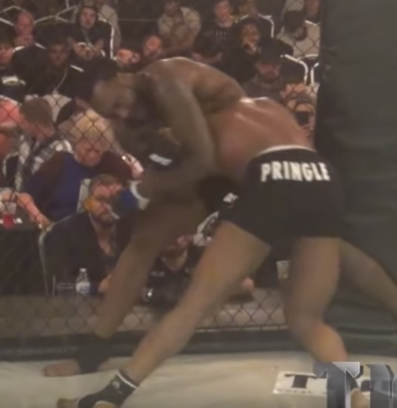

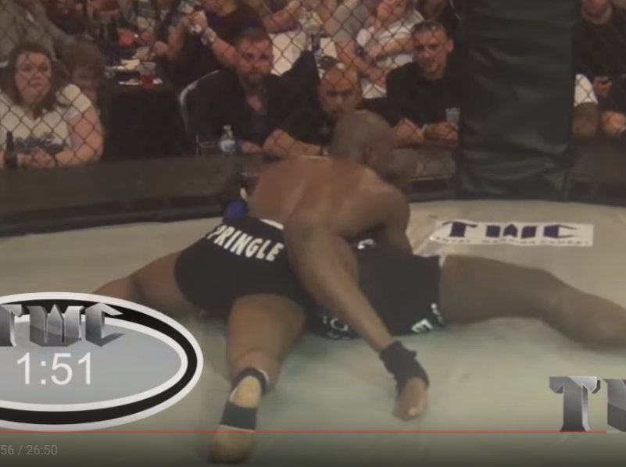
For DK: I like Lewis ($9,300) both as a cash game option (50/50s, double ups, head to heads and triple ups) and GPP play. He will very likely win and finish the fight. I will fade Townsend ($6,900).

AJ’s Flash Knockdown Picks:
Lock them in (cash games):
- Curtis Blaydes $9,000
- Montel Jackson $9,400
High priced fades:
- Arnold Allen $9,200
- Angela Hill $8,600
Low-owned GPP higher-priced fighters
- Sara McMann $8,400
- Alex Perez $9,100
Low-owned live underdogs (relative to DK pricing):
- Brett Johns $8,000
- Herbert Burns $7,900
- Lina Länsberg $7,800
- Darko Stošić $7,700
Underdogs (relative to DK pricing below $8,100) to consider in cash games:
- Nik Lentz $7,000
- Justine Kish $7,500
- Hannah Cifers $7,600
- Junior Dos Santos $7,200
- Darko Stošić $7,700

