UFC 245 Betting Breakdown
The Bets:
- Max Holloway 2.5 units @ -175
- Brandon Moreno 2.5 units @ +125
- Viviane Araujo 3 units @ -150
- Matt Brown vs. Ben Saunders FDGTD 4 units @ -265
- Daniel Teymur vs. Chase Hooper FDGTD 3 units @ -150

Max Holloway 2.5 units @ -175
It’s really hard to dethrone Holloway as the champ of this division. His elite durability, cardio, volume striking, and well-roundedness help him prevail in 5 round fights even against elite fighters of the division. Volkanovski has shown good cardio overall (noticeably slowed down in round 3 versus Elkins, but other than that, good) thus far although this is his first 5 round fight in the UFC and his first opponent he has faced that will push the tempo on him in all minutes of the fight (rather than Volkanovski primarily controlling it). Volkanovski has some power, volume, wrestling, and utilizes leg kicks (Holloway is pretty heavy on his lead leg due to his boxing-oriented style), but I do not believe that will be enough to beat Holloway in a 5-round fight. Volkanovski’s power will be mitigated due to the fact that Holloway is a solid defensive striker with a great chin, his volume will be outmatched by Max’s in the majority of the rounds (Max keeps a very high striking pace in all 5 rounds), and if Frankie Edgar did not have much success wrestling Max, I do not see how Volkanovski does despite being a bigger opponent due to Frankie’s high pedigree of wrestling. Lastly, Holloway took Aldo’s notoriously brutal leg kicks well in their second fight which leads me to believe he will take Volkanovski’s leg kicks. While I think Volkanovski can make this a competitive fight in the first couple of rounds, I do not see how he beats Max in at least 3 rounds to become a new champion. Max will have the takedown defense to keep the fight standing where is the superior technical and volume striker. And still.
Brandon Moreno 2.5 units @ +125
I like Kara-France in matchups where he can keep the fight standing AND is the superior striker relative to his opponent (which is why I bet him against De La Rosa). Moreno is Kara-France’s toughest test to date. Perplexingly, Moreno was cut by the UFC after losing two fights in a row, but he’s back and delivered in a big way in Mexico City against Askarov. Moreno is a solid wrestler, powerful striker with improving technique & defense, a good submission grappler, and has great cardio (fought at a high pace in Mexico City in 3 rounds). I noticed Kara-France has slowed down in previous fights (i.e. vs. Paiva) and I expect him to be at a submission grappling & wrestling disadvantage here. Moreno will look to push the pace as he typically does which will likely tire Kara-France out sooner than usual. Therefore, present Moreno with more opportunities to finish the fight. I believe Kara-France is the more technical striker, but by a small margin. Moreno is the more threatening and faster striker, so I see Moreno having success if this fight is standing in addition to when it goes to the mat. I favor Moreno here (hence the bet). He can win this bout if it stays standing, but should have a lot of success should this fight hit the mat.

*Against Paiva, Kara-France did not display adequate defensive wrestling. Moreno is a strong wrestler and grappler, so in positions like the below which Paiva got, I expect Moreno to execute successful takedowns.

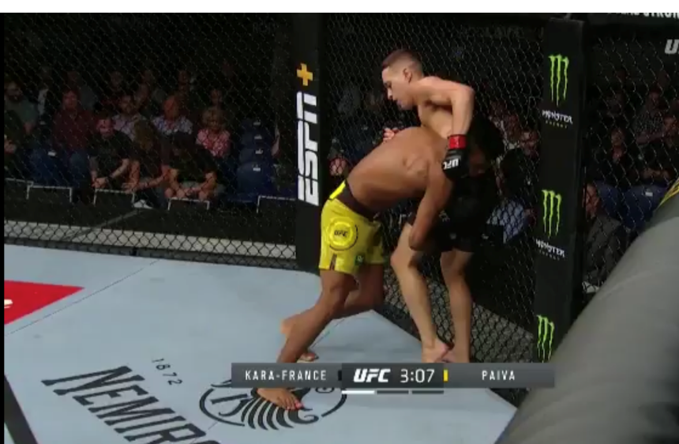

*Kara-France gave up his back against De La Rosa in his most recent fight. I expect Moreno to capitialize if face with a situation like this.

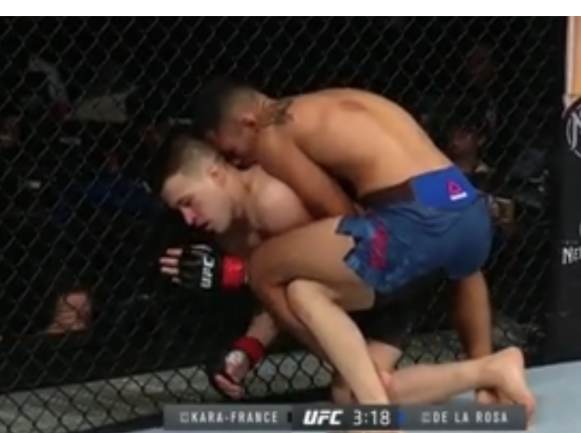
Viviane Araujo 3 units @ -150
Jessica Eye is a well-rounded fighter that is very experienced at the UFC level. The thing that sticks out to me the most about Eye is that in a lot of her fights very competitive (split) decisions occur due to her fighting style as she does not produce a lot of offensive to win rounds. Araujo is a good overall fighter. She is light on her feet, fast, has power, very credentialed in BJJ, and has a solid wrestling game. The glaring flaw I see in Araujo is her cardio management. Her cardio is not bad. It’s just she does not manage it well by moving excessively while striking. Eye may have success if Araujo slows down in round 3, but I do not see Eye doing enough to win the fight if that happens. The knockout loss and weight miss may affect Eye, but regardless I like Araujo’s chances to win this fight. I believe Araujo is the superior striker, round winner, grappler, and wrestler; hence, the pick (and bet).
*Eye gave up her back briefly against Chookagian, but was able to escape in part due to the awkward positioning of Chookagian’s left leg.
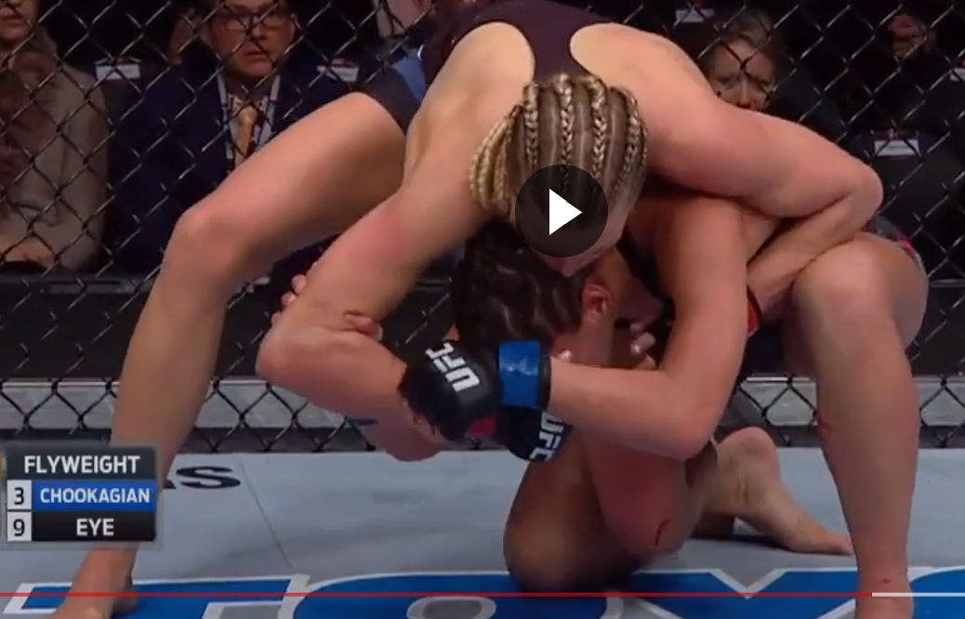

*After getting rocked by a head kick, Eye was mounted by Faria

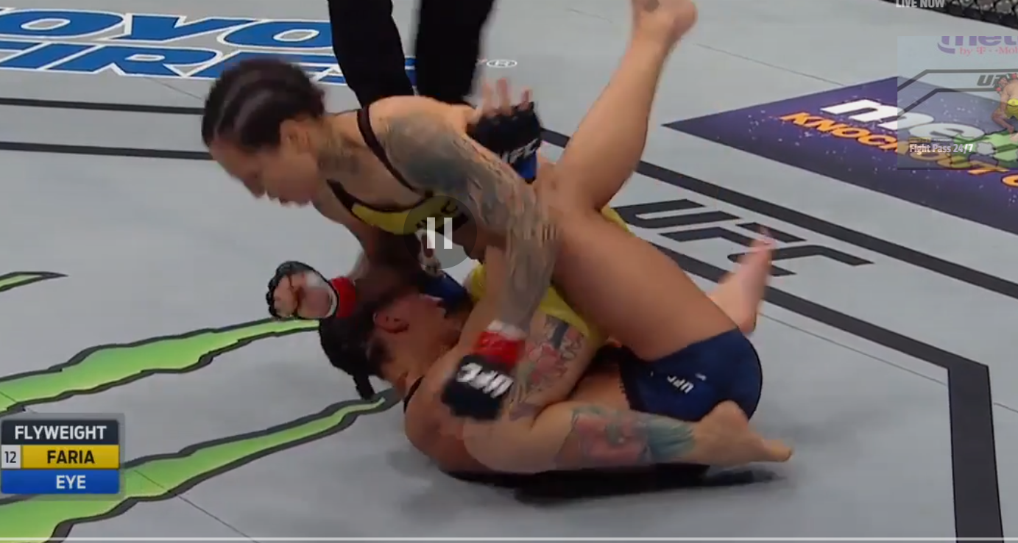

Matt Brown vs. Ben Saunders FDGTD 4 units @ -265
Two highly-experienced veterans are featured in this bout that is not likely to go a decision due to each fighters’ durability. Saunders has been finished via strikes in 5 of his last 6 bouts. Brown has been finished via strikes in 2 of his 3 most recent fights and has shown a consistent susceptibility to being hurt to the body (i.e. vs. Sanchez, Cerrone, and Ellenberger). Saunders has a great clinch game where he utilizes knees excessively and likes to throw a lot of kicks when striking at range which he can utilize against Brown. Brown undeniably has power which he can use to hurt Saunders. While I favor Brown, I do not think he should be this high of a favorite due to the fact he can be hurt to the body and Saunders likes to work the body in the clinch and in range striking. I do not expect either fighter to have much success on the mat unless one of them hurts the other with strikes. Both are credentialed grapplers and I expect them to neutralize each other on the mat assuming neither is hurt. A finish is very likely to materialize here as they both have fighting durability concerns and both have enough power to hurt each other.

Daniel Teymur vs. Chase Hooper FDGTD 3 units @ -150
This is one of those fights where one fighter has an obvious advantage in one facet of MMA (Hooper in grappling) and the opponent has an obvious advantage in another (Teymur in striking). Hooper has been rocked multiple times (on DWTNCS and on the regional scene) as his striking is not developed. However, Hooper’s grappling is very impressive as he is slick and flexible grappler & scrambler that consistently finds his way into advantageous positions which will help him in this matchup should this fight hit the ground (Teymur was submitted by Fishgold and Arce). Hooper is not a good offensive wrestler, so he is willing to pull guard to get the fight to the mat. Hooper will also have the cardio advantage here as Teymur typically gasses due to throwing his strikes with excessive force (with very little technique). Teymur’s grappling looked better in his most recent fight against Jo; however, I do not believe he improved enough to close the grappling disparity between him and Hooper. Teymur by KO/TKO or Hooper by SUB is who I see this bout finishing.

