UFC Washington D.C. Betting Breakdown
The Bets:
- Alistair Overeem 1.5 units @ -120
- Cynthia Calvillo 3 units @ +120
- Aspen Ladd 3.5 units @ -160
- Yadong Song 3 units @ -185
- Rob Font 3 units @ -145

Alistair Overeem 1.5 units @ -120
Overeem is the more technical and well-rounded MMA fighter in my opinion. I believe Overeem will test Rozenstruik’s ground game due to Rozenstruik’s shaky takedown defense and grappling that was put to test in his UFC debut versus Junior Albini (please see images below).
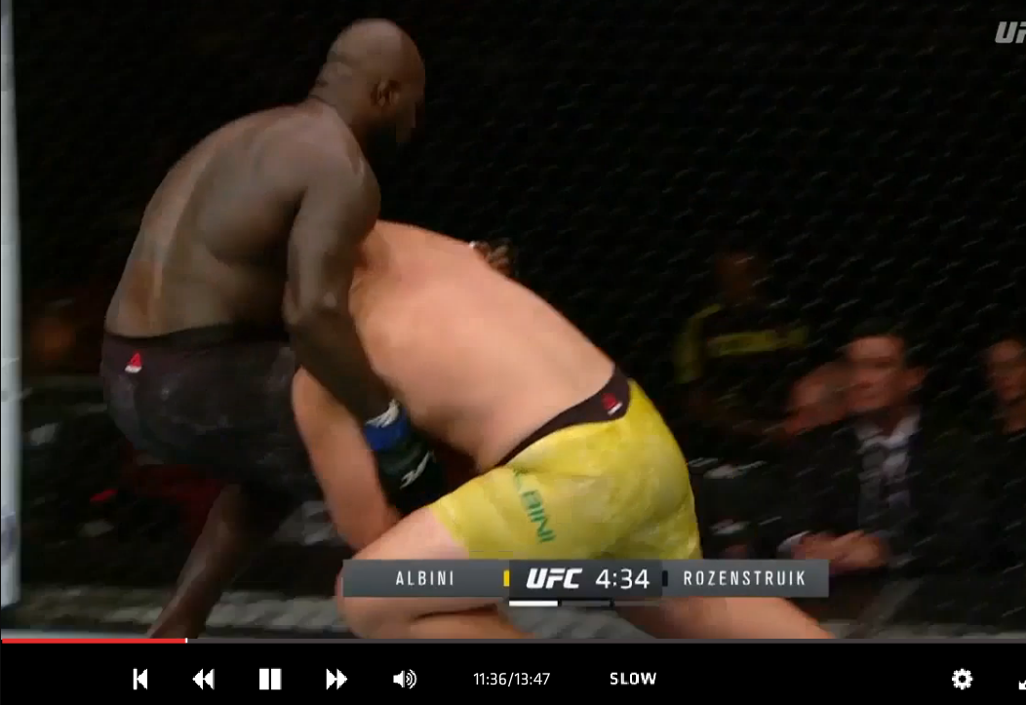

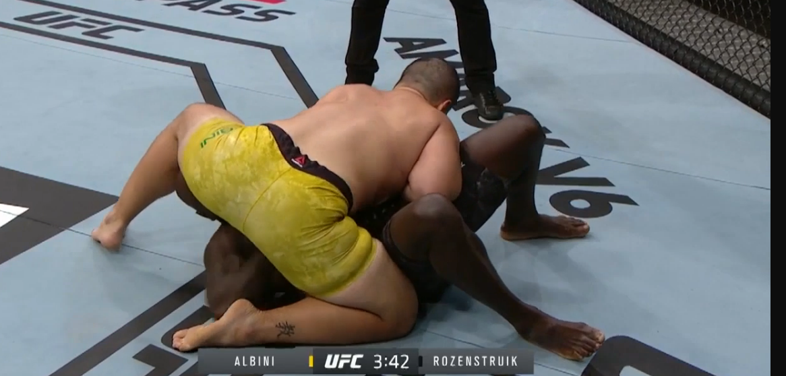

*This back take was on Albini’s second successful takedown
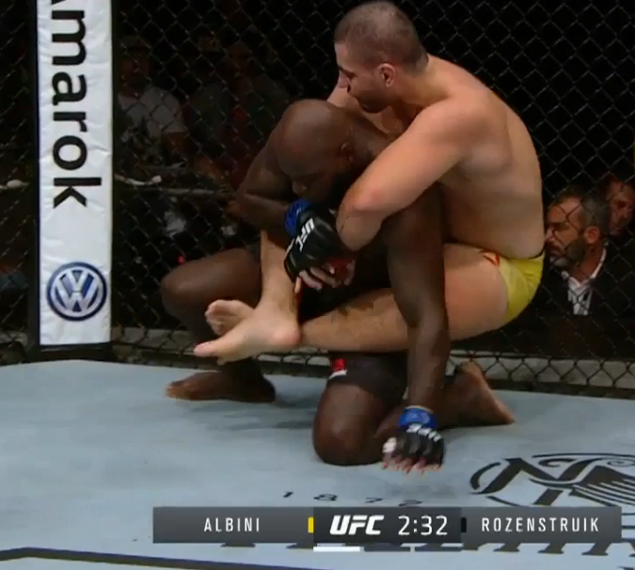

Rozenstruik undeniably has big power and Overeem has been knocked out multiple times throughout his professional fighting career, so a knockout victory is certainly a possibility for Rozenstruik. Hence, why this is only a 1.5 unit bet and not more. Overeem is a very cautious striker at this point in his career and focusing more on counterstriking, thus, mitigating his opponent’s offensive attack. I think Overeem can win this fight via striking, but taking this fight to the ground (like he did versus Pavlovich) would be the path of least resistance. Rozenstruik allowed Albini to walk him down and land effective offense in his UFC debut and the two following fights ended very early in his favor. I favor Overeem’s striking and his ground game over Rozenstruik.

Cynthia Calvillo 3 units @ +120
This fight is very clearly striker (Rodriguez) versus grappler (Calvillo). However, I see this fight as competitive in the striking department. Calvillo’s striking is much looser and she’s also showcased good footwork, cardio, and leg kicks (Rodriguez is heavy on her lead leg). I see Rodriguez having most of her success striking in the clinch which may play right into the takedown threat of Calvillo due to the fact they will be in close range and Calvillo will have an easier time grabbing ahold of Rodriguez. Also, Rodriguez throws a lot of naked front kicks which Calvillo can capitalize on by catching one and taking Rodriguez down where I believe she will have a BIG advantage in grappling. Calvillo is a really smooth grappler and quick scrambler (took Calderwood’s back when they fought) – please see below.
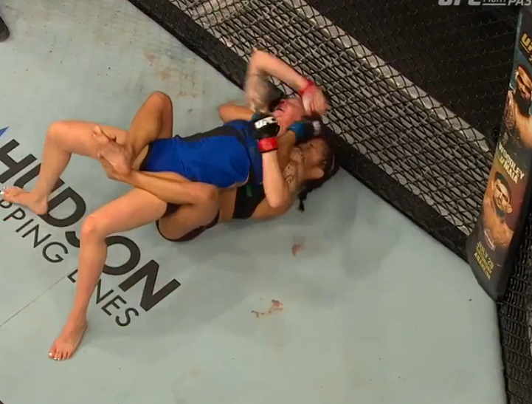

Also, based off the success Markos had in Rodriguez’s UFC debut grappling and wrestling, I see Calvillo as having even more success should this fight go to the mat. Please note the time (more than three minutes) in the first round where Markos was in mount (right after she took Rodriguez down) and then transitioned to side control. Has Rodriguez takedown defense looked decent overall? Yes, but, as previously mentioned, she does throw a lot of naked front kicks which I’ve seen Calvillo take advantage of by catching kicks in previous fights and taking her opponents down.

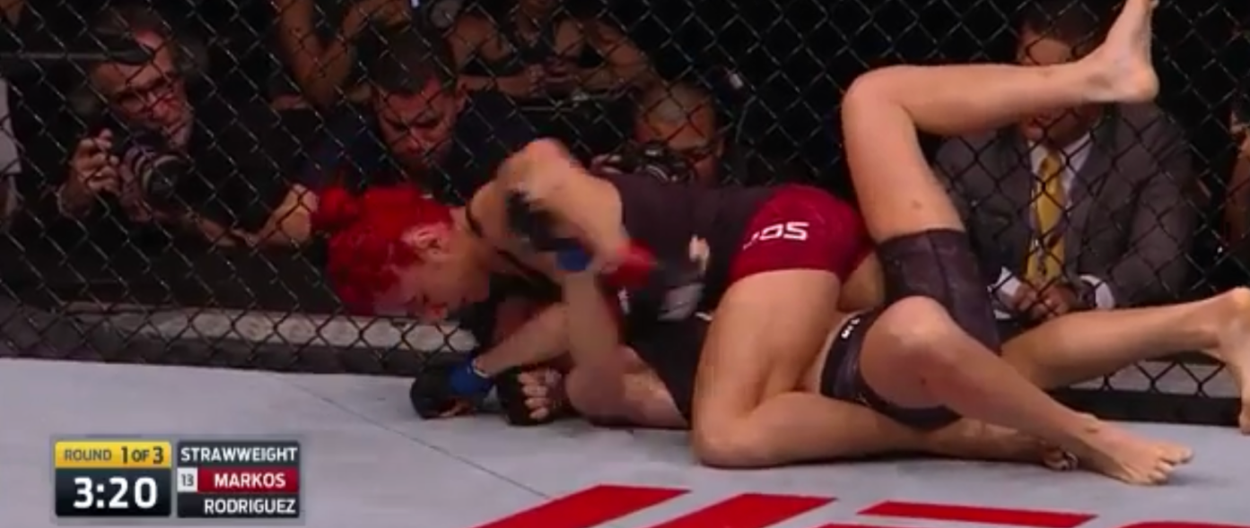
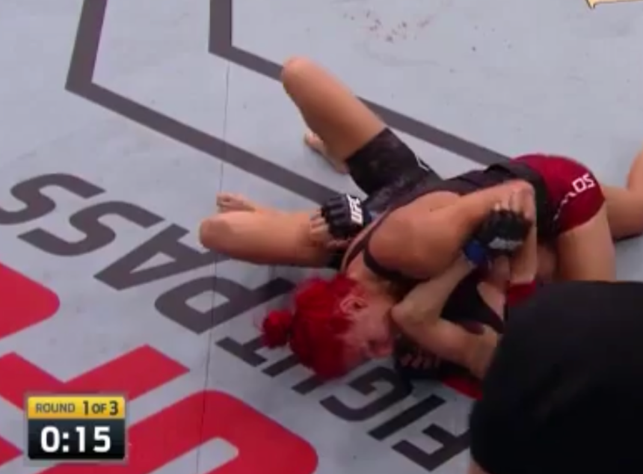

Calvillo has the advantage on the mat where I think she will take the fight and can even win in the striking department by have more output and landing more effective strikes than Rodriguez.

Aspen Ladd 3.5 units @ -160

I believe the odds on this fight are close due to Ladd’s most recent loss. It was controversial, but regardless, it goes down as a TKO loss in the first round. I am still high on Ladd though as a fighter. Her striking can be improved, but she is a very strong and aggressive grappler which is a skillset I rate highly. Ladd will be at the striking disadvantage here, but I believe Kunitskaya is not nearly as threating nor technical of a striker as Germaine De Randamie. Therefore, I do not expect Ladd to be in any danger while this fight stays standing. Where I believe Ladd wins this fight by landing takedowns and utilizing her strong top control to land significant strikes aggressively. I believe Ladd will have a strength advantage and Kunitskaya’s takedown defense has not fared well against fellow contenders in the division (please see below). Against Marion Reneau, Kunitskaya (similar to Marina Rodriguez), likes to utilize naked front kicks which led her to getting taken down. Kunitskaya also throws a good amount of ill-advised spinning back fists which can certainly led to Ladd closing distance, grabbing Kunitskaya’s back, and taking the fight to the ground.

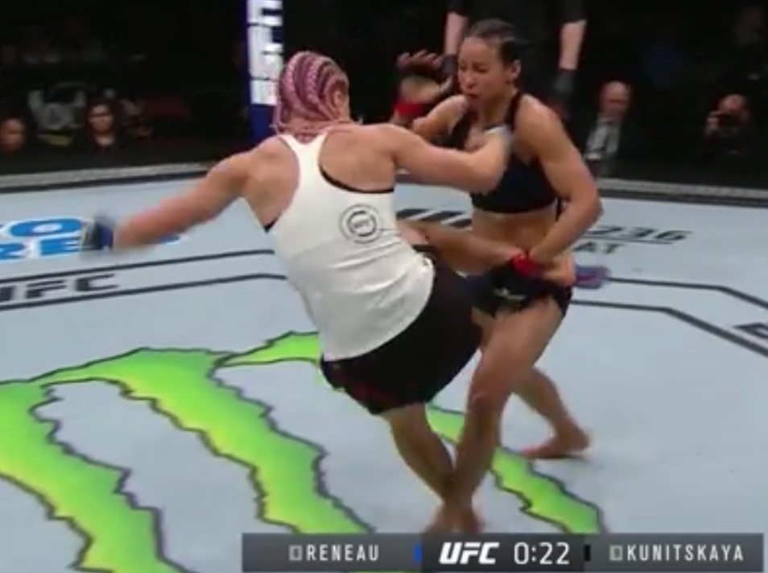

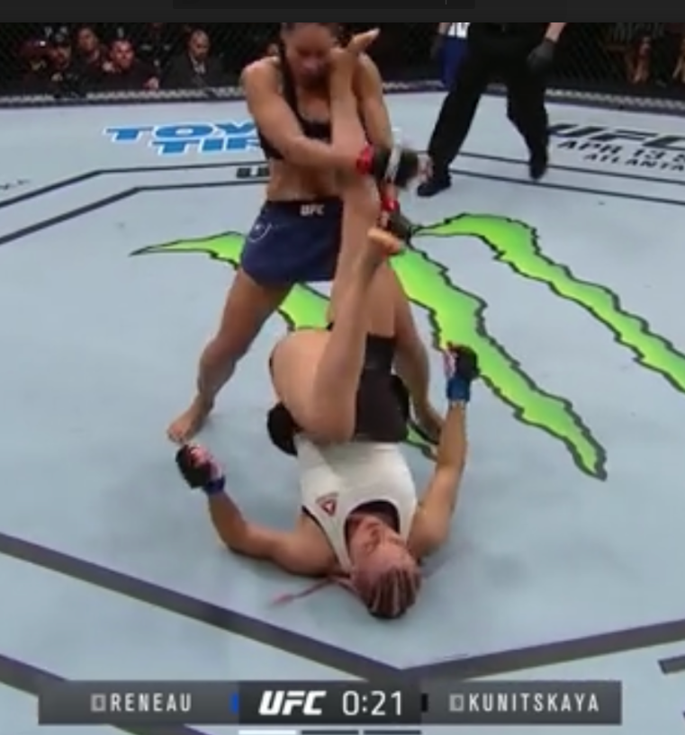
*Against Tonya Evinger in Invicta

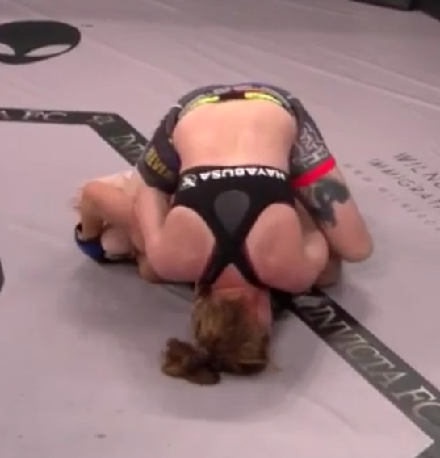

I believe Ladd will land a takedown (or more if she does not finish the fight after the first successful one) and win the fight via ground and pound.

Yadong Song 3 units @ -185
Stamann did not look good in his fight following his first finish loss of his MMA career (against Sterling via submission) against Alejandro Perez as he really struggled to land (and defend) takedowns against an inferior wrestler on paper. The injury Stamann sustained looked excruciating. Images on what I am referencing are below.

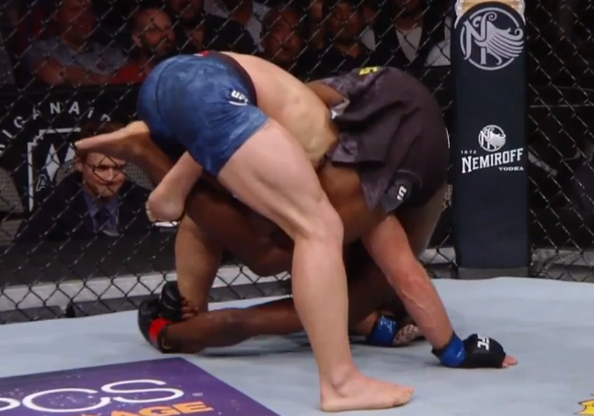

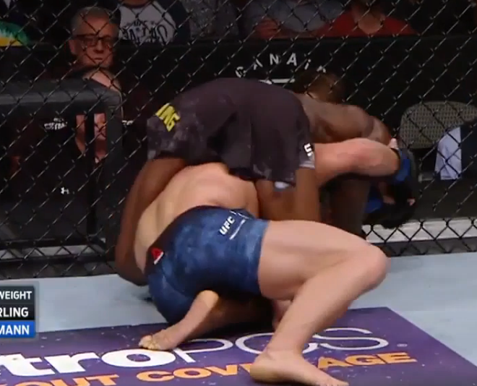

*Understandably, Stamann instantly tapped upon the submission attempt from Sterling as it was extremely painful for him.
In the fight with Sterling and in his previous fights, Stamann was able to land takedowns effectively, but with his threat of offensive takedowns being suppressed, it’s going to be a tough matchup for him against fellow prospect, Song Yadong. Stamann is a decent striker, but I favor Yadong in the striking department as I believe he is more technical, powerful, varied, faster, and fluid. Yadong is a good wrestler himself and is well credentialed in BJJ as he showcased against Felipe Arantes by nearly submitting him with an arm triangle choke (please see below).
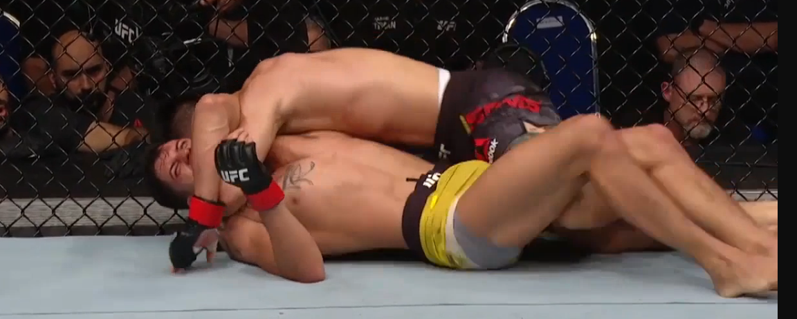
Yadong’s takedown defense has not been tested often in the UFC yet, but he has trained at Team Alpha Male (a camp with a lot of talented wrestlers including Josh Emmett, Cody Garbrandt, and Uriah Faber) and has high-level athleticism. Additionally, Stamann’s recent performance (referencing the bout against Perez) leads me to believe Stamann will be unsuccessful landing takedowns against Yadong.

I actually believe Yadong is more likely to win this bout by finish by method of submission rather than knockout (Stamann has not been knocked out in 20 pro MMA fights) as Stamann has shown very questionable submission grappling. Not just in the Sterling fight, but in the two times the fight against Caraway hit the ground, he had his guard passed & was put in submission attempts (please see below).

*In the first round against Caraway
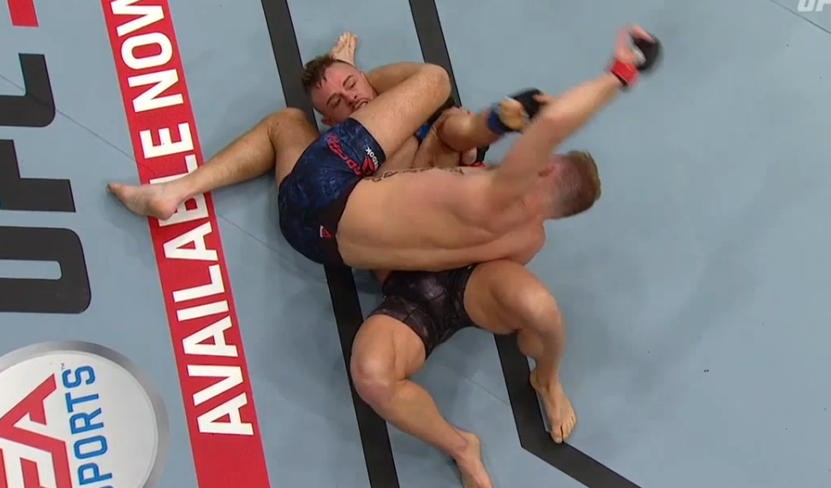
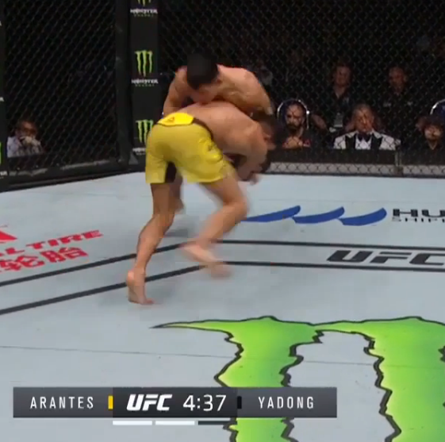
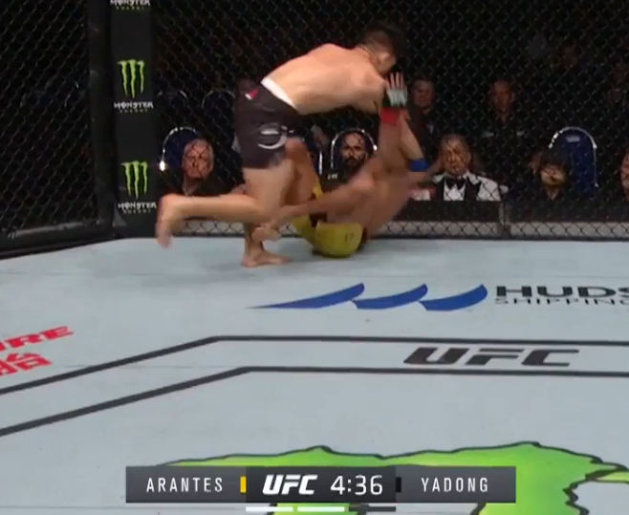

*In the third round against Bryan Caraway

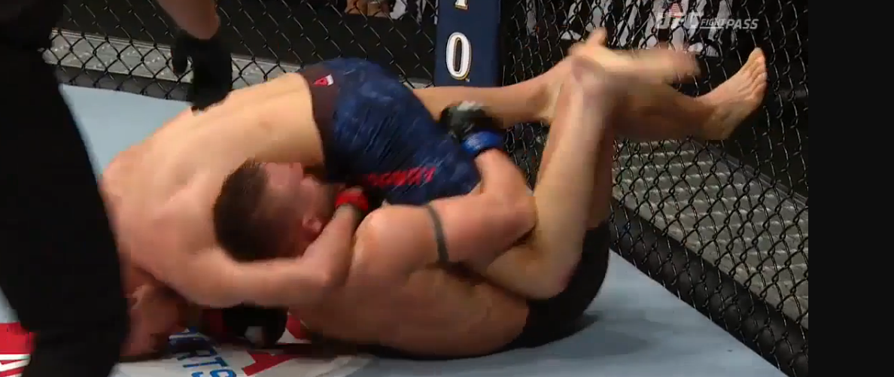
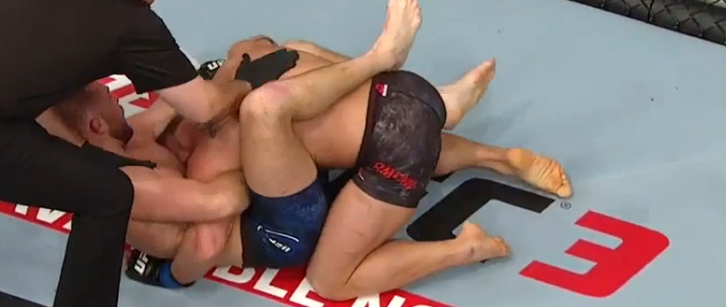

Rob Font 3 units @ -145
Simon is coming off his first TKO/KO loss of his career. Prior to the 1st round loss to Faber in July, Simon had been rocked by Dvalishvili and Yahya. Font certainly has power so I expect Font to test Simon’s durability again. Font is the better striker in my opinion due to his superior technique, output, and power. I also believe Font is the better BJJ practitioner, but Font can be taken down (i.e. versus Assuncao).
The thing that is different from being taken down and controlled from Raphael Assuncao rather than a fighter like Ricky Simon is the submission grappling disparity. A high level in submission grappler in top position inhibits a more cautious approach from the fighter on bottom (and when they are attempting to get back to their feet), but Font is the better submission grappler in my opinion (between him and Simon), so I do not see Simon controlling him, threatening with chokes, nor landing a lot of ground and pound. Also, I do not consider Simon a good top control wrestler and with Font being a decent wrestler & the superior submission grappler, I believe Simon will not have a lot of success with top-control wrestling here. The matchup favors Font in my opinion. Font can win this fight on the ground (he is a good submission grappler with a good guillotine choke) or in the striking department.

*Shown in the following images - Font getting a very impressive reversal in his last outting inside the UFC octagon against Sergio Pettis

